Electoral Systems

TOPIC |  | NOTES |  |  | ✓
Purposes of Elections
- Choosing Govt
- Accountability
- Legitimacy
- Representation
- Participation
- Education
- Influence over policy
- Elite recruitment
- Mandate
Representation
- Delegate
- Trustee
- Party/Constituency/Society/Self
First Past the Post
- How it works
- Effects
- Pros and Cons
- 2005/2010 Westminster
Additional Member System
- How it works
- D’Hondt Formula
- Pros and Cons
- Scot/Wales elections
Alternative Vote/AV Plus
- How it works
- Pros and Cons
- ConDems Proposals
Supplementary Vote
- How it works
- Pros and Cons
- London Mayoral Elections
Single Transferable Vote
- How it works
- Droop Quota
- Pros and Cons
- Northern Irish Elections
Party List (Open/Closed)
- How it works
- Pros and Cons
- European Elections
Impact of New Systems
- Proportionality
- Multi-party systems
- Minority/Coalition govts
- Split-ticket voting
Electoral Reform
- For and Against
Elections vs. Referendums
- What is a Referendum?
- Pros and Cons
- Examples of use
Key Terms | Accountability  Mandate  Legitimacy  Manifesto  Constituency  Representation  Participation  Majority  Apathy  Hybrid System |  | Majoritarian  Proportional Representation  Simple Plurality  Mixed system  Alternative Vote  Supplementary Vote  Additional Member System  First Past the Post  Open/Closed Party List  Single Transferable Vote | Wasted Votes  Delegate  Trustee  Two Party System  Multi Party System  Winner’s Bonus  Tactical Voting  Safe Seat  Preferential Voting  Jenkins Commission

Prezi

https://prezi.com/b2uqqg8mcxdr/as-uk-electoral-systems/

Specification
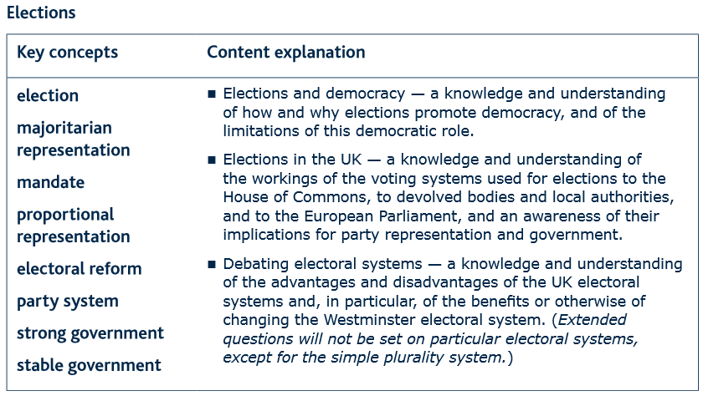

Past Paper Questions

5 marks  Describe three elections regularly held in the UK (5) June 2015 NEW  Outline two functions of elections (5) June 2014 NEW  Outline the workings of the Single Transferable Vote electoral system. (5) Jun 2013 NEW  What is meant by the term ‘party system’? (5) Jan 2013 NEW  Describe three different elections regularly held in the UK (5) June 2012 NEW  Outline the workings of the Party List electoral system (5) Jan 2012 NEW  Distinguish between a mandate and a manifesto (5) June 2011 NEW  How do elections promote democracy? (5) Jan 2011 New  Outline two functions of elections (5) Jun 2010 New  Define proportional representation (5) Jan 2010 New  What is the doctrine of the mandate? (5) Jun 2009 New  Outline the workings of the Additional member System (AMS) (5) Jan 2009 New  Briefly explain two functions of a general election (5) 2009  Distinguish between and election and a referendum (5) 2008  Define proportional representation (5) Jan 2008  What is a referendum? (5) 2007  Outline two features of the ‘first past the post’ electoral system. (5) 2006  What is a referendum? (5) Jan 2006  What is proportional representation? 2005  Outline two differences between referendums and general elections (5) Jan 2005  Outline the features of the ‘first-past-the-post’ electoral system (5) 2004 | 10 marks  Explain three strengths of the ‘first past the post’ electoral system. (10) June 2015 NEW  Explain the workings of three electoral systems used in the UK (10) June 2014 NEW  Using examples, distinguish between a two-party system and a multi-party system. (10) Jun 2013 NEW  Explain how and why party representation may be affected by any three different electoral systems. (10) Jan 2013 NEW  Explain three strengths of the ‘first past the post’ electoral system. (10) June 2012 NEW  Explain three criticisms of the ‘first past the post’ electoral system. (10) Jan 2012 NEW  Explain the workings of three electoral systems used in the UK (10) June 2011 NEW  Distinguish between majoritarian representation and proportional representation (10) Jan 2011 New  Explain three advantages of the ‘first past the post’ electoral system (10) Jun 2010 New  Explain why proportional electoral systems have been more widely used in the UK since 1997 (10) Jan 2010 New  Explain the workings of three electoral systems used in the UK. (10) Jun 2009 New  How has the use of AMS affected party representation in the UK? (10) Jan 2009 New  Describe the workings and main implications of the ‘first past the post’ electoral system (10) 2009  Why have more referendums been used in the UK since 1997? (10) 2008  Explain the workings of three electoral systems in the UK (10) Jan 2008  Explain the circumstances of three referendums held in the UK since 1997 (10) 2007  Explain the workings of three other electoral systems which are used in the UK (10) 2006  Why have referendums been used more frequently in the UK since 1997? (10) Jan 2006  Explain the workings of the Additional Member System and the Single Transferable Vote in the UK (10) 2005  Describe the circumstances in which three referendums have been held in the UK (10) Jan 2005  Describe three other electoral systems which are currently used in the UK (10) 2004
25 marks
To what extent do the differing electoral systems used in the UK produce different outcomes? (25) June 2015 NEW
Assess the advantages of the various electoral systems used in the UK (25) June 2014 NEW
Should ‘first past the post’ continue to be used for elections to the House of Commons? (25) Jun 2013 NEW
Assess the advantages of using proportional representation electoral systems. (25) Jan 2013 NEW
To what extent do the different electoral systems used in the UK produce different outcomes? (25) June 2012 NEW
Make out a case in favour of retaining the ‘first past the post’ electoral system for the House of Commons. (25) Jan 2012 NEW
Should the Westminster electoral system be reformed? (25) June 2011 NEW
How far does the Westminster electoral system ensure strong and stable government? (25) Jan 2011 New
Make out a case in favour of the introduction of proportional representation for Westminster elections (25) Jun 2010 New
Assess the criticisms of the various electoral systems used in the UK (256) Jan 2010 New
Assess the advantages of the ‘first past the post’ electoral system (25) Jun 2009 New
Should proportional representation be introduced for elections to the House of Commons? (25) Jan 2009 New
In what ways, and to what extent, have proportional electoral systems had an impact in the UK? (25) 2009
Are referendums more effective than elections in promoting democracy? (25) 2008
To what extent have proportional electoral systems affected party representation in the UK? (25) Jan 2008
Do referendums strengthen or weaken the power of government? (25) 2007
How do the different UK electoral systems affect the representation of political parties (25) 2006
To what extent do referendums promote democracy? (25) Jan 2006
To what extent has the use of more proportional electoral systems affected the political process in the UK? (25) 2005
State the case against the use of referendums (25) Jan 2005
Analyse how these other electoral systems have affected the representation of political parties in the UK (25) Jan 2004

