Q1.
Figure 1 is a graph that shows the time it takes to travel between six locations in a warehouse. The six locations have been labelled with the numbers 1 - 6. When there is no edge between two nodes in the graph this means that it is not possible to travel directly between those two locations. When there is an edge between two nodes in the graph the edge is labelled with the time (in minutes) it takes to travel between the two locations represented by the nodes.
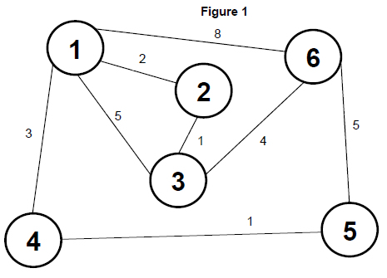
(a) The graph is represented using an adjacency matrix, with the value 0 being used to indicate that there is no edge between two nodes in the graph.
A value should be written in every cell.
Complete the unshaded cells in Table 1 so that it shows the adjacency matrix for Figure 1.

Table 1
 | 1 | 2 | 3 | 4 | 5 | 6
1
2
3
4
5
6
(2)
(b) Instead of using an adjacency matrix, an adjacency list could be used to represent the graph. Explain the circumstances in which it would be more appropriate to use an adjacency list instead of an adjacency matrix.
___________________________________________________________________
___________________________________________________________________
___________________________________________________________________
___________________________________________________________________
(2)
(c) State one reason why the graph shown in Figure 1 is not a tree.
___________________________________________________________________
___________________________________________________________________
(1)
(d) The graph in Figure 1 is a weighted graph. Explain what is meant by a weighted graph.
___________________________________________________________________
___________________________________________________________________
(1)
Figure 2 contains pseudo-code for a version of Djikstra’s algorithm used with the graph in Figure 1.
Q is a priority queue which stores nodes from the graph, maintained in an order based on the values in array D. The reordering of Q is performed automatically when a value in D is changed.
AM is the name given to the adjacency matrix for the graph represented in Figure 1.
Figure 2
Q ← empty queue
FOR C1 ← 1 TO 6
D[C1] ← 20
P[C1] ← −1
ADD C1 TO Q
ENDFOR
D[1] ← 0
WHILE Q NOT EMPTY
U ← get next node from Q
remove U from Q
FOR EACH V IN Q WHERE AM[U, V] > 0
A ← D[U] + AM[U, V]
IF A < D[V] THEN
D[V] ← A
P[V] ← U
ENDIF
ENDFOR
ENDWHILE
OUTPUT D[6]
(e) Complete the unshaded cells of Table 2 to show the result of tracing the algorithm shown in Figure 2. Some of the trace, including the maintenance of Q, has already been completed for you.
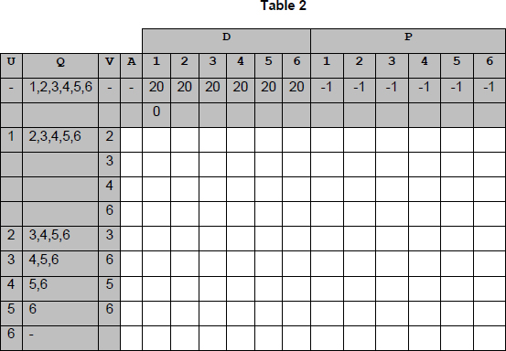
(7)
(f) What does the output from the algorithm in Figure 2 represent?
___________________________________________________________________
___________________________________________________________________
(1)
(g) The contents of the array P were changed by the algorithm. What is the purpose of the array P?
___________________________________________________________________
___________________________________________________________________
___________________________________________________________________
___________________________________________________________________
(2)
(Total 16 marks)
Q2.

(a) Figure 1 shows four graphs, labelled with the letters A to D.
Figure 1
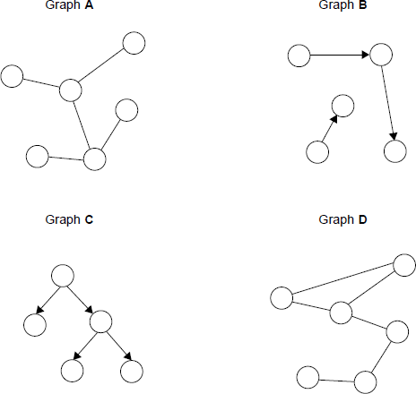
Complete Table 1 below. In the Correct letter (A-D) column write the appropriate letter from A to D to indicate which graph in Figure 1 matches the description in the Description column.
Do not use the same letter more than once. You will not need to use all of the letters.
Table 1

Description | Correct letter (A-D)
A graph that is not connected
A graph that is a tree
(2)
(b) It is possible to represent a computer network as a graph, with each vertex representing a router and each edge representing a communications link.
Figure 2 is a graph representation of a medium-sized computer network that consists of 6 routers and 7 communications links. The routers have been numbered from 1 to 6.
Figure 2
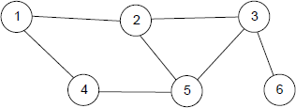
Complete Table 2 below to show how the graph in Figure 2 would be stored using an adjacency matrix.
Table 2
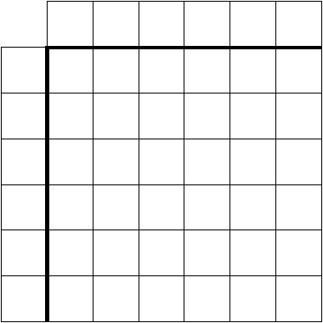
(2)
(c) Figure 2 is repeated here.
Figure 2 (Repeated)
A simple method of determining the shortest path through a network from one router to another is to perform a breadth first search of the graph representation of the network.
The algorithm in Figure 3 can be used to perform a breadth first search of a graph. It makes use of two subroutines, PutVertexIntoQueue and GetVertexFromQueue, which are explained below the algorithm.
Figure 3
Procedure ShortestRoute(S, D)
PutVertexIntoQueue(S)
Discovered[S] True
Found False
While Queue is Not Empty And Found = False Do
V = GetVertexFromQueue
For each vertex U which is adjacent to V Do
If Discovered[U] = False And Found = False Then
PutVertexIntoQueue(U)
Discovered[U] True
Parent[U] V
If U = D Then Found True
EndIf
EndFor
EndWhile
If Found = True Then
C D
Output D
Repeat
C Parent[C]
Output C
Until C = S
EndIf
EndProcedure
• PutVertexIntoQueue is a subroutine that adds a vertex to the rear of a queue.
• GetVertexFromQueue is a subroutine that returns the name of the vertex at the front of the queue and removes it from the queue.
Complete the trace table below to show how the Discovered and Parent arrays, the variable Found and the queue contents are updated, together with what output is produced by the algorithm when it is called using ShortestRoute(1, 6).
Before the algorithm is carried out, all cells in the Discovered array are set to the value False and the queue is empty.
The values of the variables S, D, V, U and C have already been entered into the table for you.
The letter F has been used as an abbreviation for False. You should use T as an abbreviation for True.
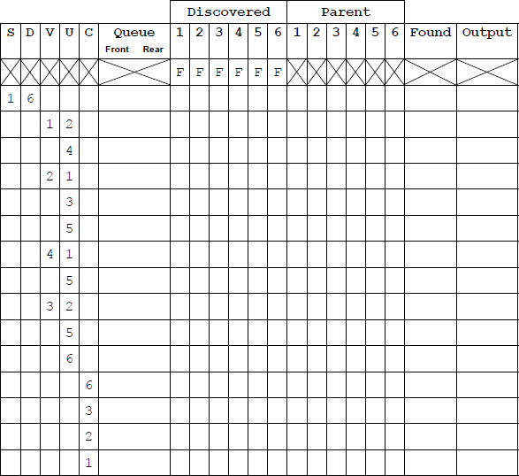
(6)
(d) Explain why it is useful to find the shortest path through the network.
___________________________________________________________________
___________________________________________________________________
(1)
(Total 11 marks)
Q3.
A graph can be drawn to represent a maze. In such a graph, each graph vertex represents one of the following:
• the entrance to or exit from the maze
• a place where more than one path can be taken
• a dead end.
Edges connect the vertices according to the paths in the maze.
Diagram 1 shows a maze and Diagram 2 shows one possible representation of this maze.
Position 1 in Diagram 1 corresponds to vertex 1 in Diagram 2 and is the entrance to the maze. Position 7 in Diagram 1 is the exit to the maze and corresponds to vertex 7.
Dead ends have been represented by the symbol in Diagram 2.
Diagram 3 shows a simplified undirected graph of this maze with dead ends omitted.
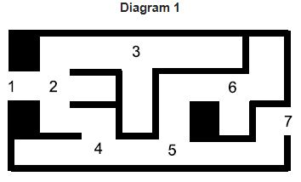

Diagram 2 | Diagram 3
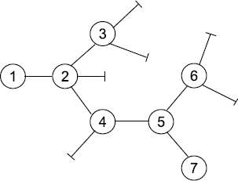 | 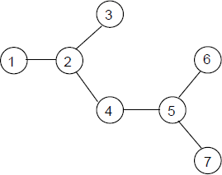
Representation of maze  including dead ends | Graph representing maze  with dead ends omitted
(a) The graph in Diagram 3 is a tree.
State one property of the graph in Diagram 3 that makes it a tree.
___________________________________________________________________
___________________________________________________________________
(1)
(b) The graphs of some mazes are not trees.
Describe a feature of a maze that would result in its graph not being a tree.
___________________________________________________________________
___________________________________________________________________
(1)
(c) Complete the table below to show how the graph in Diagram 3 would be stored using an adjacency matrix.
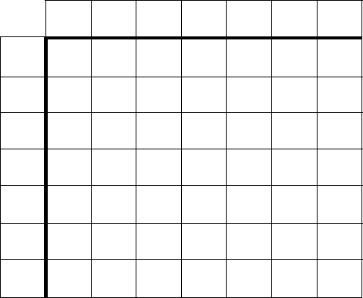
(2)
(d) (i) What is a recursive routine?
______________________________________________________________
______________________________________________________________
(1)
(ii) To enable the use of recursion a programming language must provide a stack.
Explain what this stack will be used for and why a stack is appropriate.
______________________________________________________________
______________________________________________________________
______________________________________________________________
______________________________________________________________
(2)

Diagram 3 is repeated here so that you can answer Question (e) without having to turn pages.
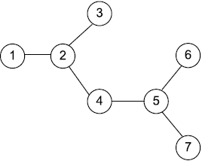
(e) A recursive routine can be used to perform a depth-first search of the graph that represents the maze to test if there is a route from the entrance (vertex 1) to the exit (vertex 7).
The recursive routine in the diagram below is to be used to explore the graph in Diagram 3. It has two parameters, V (the current vertex) and EndV (the exit vertex).
Procedure DFS(V, EndV)
Discovered[V] ← True
If V = EndV Then Found ← True
For each vertex U which is connected to V Do
If Discovered [U] = False Then DFS(U, EndV)
EndFor
CompletelyExplored[V] ← True
EndProcedure
Complete the trace table below to show how the Discovered and CompletelyExplored flag arrays and the variable Found are updated by the algorithm when it is called using DFS(1,7).
The details of each call and the values of the variables V, U and EndV have already been entered into the table for you. The letter F has been used as an abbreviation for False. You should use T as an abbreviation for True.
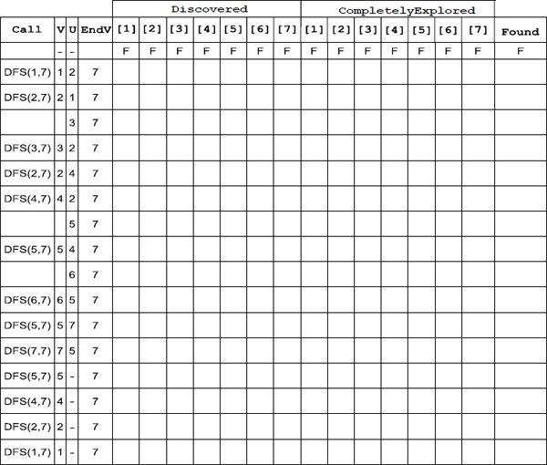
(5)
(Total 12 marks)
Q4.
The table below shows an adjacency matrix representation of a directed graph (digraph).
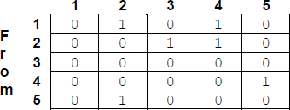
(a) Complete this unfinished diagram of the directed graph.
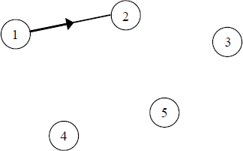
(2)
(b) Directed graphs can also be represented by an adjacency list.
Explain under what circumstances an adjacency matrix is the most appropriate method to use to represent a directed graph, and under what circumstances an adjacency list is more appropriate.
___________________________________________________________________
___________________________________________________________________
___________________________________________________________________
(2)
(c) A tree is a particular type of graph.
What properties must a graph have for it to be a tree?
___________________________________________________________________
___________________________________________________________________
___________________________________________________________________
(2)
(d) Data may be stored as a binary tree.
Show how the following data may be stored as a binary tree for subsequent processing in alphabetic order by drawing the tree. Assume that the first item is the root of the tree and the rest of the data items are inserted into the tree in the order given.
Data items: Jack, Bramble, Snowy, Butter, Squeak, Bear, Pip

(3)
(e) A binary tree such as the one created in part (d) could be represented using one array of records or, alternatively, using three one-dimensional arrays.
Describe how the data stored in the array(s) could be structured for one of these two possible methods of representation.
___________________________________________________________________
___________________________________________________________________
___________________________________________________________________
___________________________________________________________________
___________________________________________________________________
___________________________________________________________________
___________________________________________________________________
___________________________________________________________________
(3)
(Total 12 marks)
Q5.
Figure 1 shows a simpler example of a type of logic puzzle with fewer cells. In this simpler puzzle only the letters A-D are used.
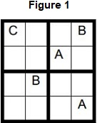
It is possible to represent this type of puzzle as a graph. To do this a unique number is given to each cell and a node containing this unique number is added to the graph. An edge between two nodes denotes a link between those two cells, meaning they cannot contain the same letter as each other.
Figure 2 shows how unique numbers have been allocated to each cell in the puzzle in Figure 1 and Figure 3 shows an adjacency matrix that represents this puzzle.
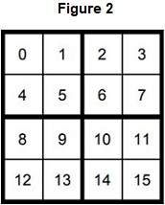
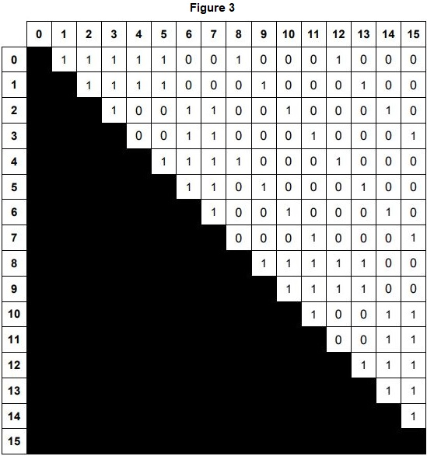
The graph in Figure 3 can be considered to be both a representational abstraction and an abstraction by generalisation of the puzzle from Figure 1.
Only the top half of the matrix in Figure 3 needed to be used to present the puzzle. For which type of graph would the bottom half of the matrix also need to be used?
_______________________________________________________________________
_______________________________________________________________________
(Total 1 mark)
Q6.
A binary search tree can be used to represent a list of data so that it can be efficiently searched. Figure 1 shows an example of a binary search tree:
Figure 1
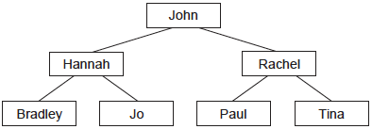
(a) The tree in Figure 1 is to be searched for data item "Lisa". The tree does not contain "Lisa".
List the data items that will be examined, in the order that they will be visited, when "Lisa" is searched for.
___________________________________________________________________
(1)
(b) Tick one box in the table to indicate the time complexity of the algorithm used to search for data in a binary search tree.

 | Time Complexity | Tick one box
 | O(n)
 | O(log n)
 | O(n²)
(1)
(c) In Figure 2 below, show how the tree in Figure 1 could be represented by a Start Index, together with a one-dimensional array of records, each of which contains the fields Left Pointer, Data and Right Pointer:
Figure 2

 |  | Index | Left Pointer | Data | Right Pointer
 |  | [1]
Start Index |  | [2]
 |  | [3]
= ________ |  | [4]
 |  | [5]
 |  | [6]
 |  | [7]
(3)
(d) The array shown in Figure 2 is an example of a static data structure.
Explain the differences between a static data structure and a dynamic data structure, and what the heap is used for with a dynamic data structure.
___________________________________________________________________
___________________________________________________________________
___________________________________________________________________
___________________________________________________________________
___________________________________________________________________
___________________________________________________________________
___________________________________________________________________
___________________________________________________________________
___________________________________________________________________
___________________________________________________________________
(3)
(e) An in-order traversal is carried out on the binary tree in Figure 1 to output the values stored in the nodes of the tree.
Figure 1
(i) Write out the data items from the tree, in the order that they will be output during the traversal.
______________________________________________________________
______________________________________________________________
(1)
(ii) What is the significance of the order that the data items have been output in?
______________________________________________________________
______________________________________________________________
______________________________________________________________
(1)
(f) Graph traversal is a more complex problem than tree traversal. State one feature that a graph might have, which a tree cannot have, that makes graph traversal more complex.
___________________________________________________________________
___________________________________________________________________
(1)
(Total 11 marks)
Q7.
A tree can be used to represent a mathematical expression. This is known as an expression tree. Figure 1 is an expression tree for the infix expression 4 + 9 * 6.
Figure 1
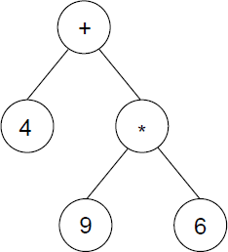
(a) An expression tree is an example of a rooted tree.
State the contents of the root node:___________________________
List the contents of all of the leaf nodes: _______________________
(2)
(b) The expression tree in Figure 1 could be represented using three one-dimensional arrays named A, B and C. Figure 2 shows a representation of Figure 1 together with the array indices.
Figure 2
Arrays
Index | A |  | B |  | C
[1] | + |  | 2 |  | 3
[2] | 4 |  | 0 |  | 0
[3] | * |  | 4 |  | 5
[4] | 9 |  | 0 |  | 0
[5] | 6 |  | 0 |  | 0
Describe the role of each of the arrays A, B and C.
A: _________________________________________________________________
B: _________________________________________________________________
C: _________________________________________________________________
(3)
(c) What does an entry of 0 in array B indicate?
___________________________________________________________________
___________________________________________________________________
(1)
(d) The procedure in Figure 3 describes a type of tree traversal that can be carried out on the representation of the tree shown in Figure 2.
Figure 3
Procedure Traverse(Pos:Integer)
If B[Pos] > 0 Then Traverse(B[Pos])
If C[Pos] > 0 Then Traverse(C[Pos])
Output A[Pos]
End Procedure
Using the table below, trace the execution of the procedure when it is called using Traverse(1). You may not need to use all of the lines provided in the table.

Pos | Output
(4)
(e) Which type of tree traversal does the procedure Traverse carry out?
___________________________________________________________________
(1)
(f) What does the output of the procedure represent?
___________________________________________________________________
(1)
(Total 12 marks)
Q8.

A computer program stores a list of integers in an array named List. The numbers in the array are to be sorted into ascending order so that a particular efficient search algorithm can be used to search for a number.
(a) One of the search algorithms in Table 1 can only be used successfully on a sorted list.
Place one tick next to the name of the algorithm that requires a list to be sorted.
Table 1

Algorithm Name | Requires Sorted List?  (Tick one box)
Binary search
Linear search
(1)
(b) The pseudo-code for a standard algorithm that can be used to sort the data in the array List into order is shown in Figure 1. The variable ListLength stores a count of the number of items in the array List.
Array indexing starts at 1.
Figure 1
For OuterPointer ← 2 To ListLength
CurrentValue ← List[OuterPointer]
InnerPointer ← OuterPointer - 1
While InnerPointer > 0 And
List[InnerPointer] > CurrentValue Do
List[InnerPointer + 1] ← List[InnerPointer]
InnerPointer ← InnerPointer - 1
EndWhile
List[InnerPointer + 1] ← CurrentValue
EndFor
Complete the empty (unshaded) cells in the trace table (Table 2) for an execution of the algorithm in Figure 1 when the array List contains the values 9, 8, 5 and 6 in that order.
Table 2

 |  |  |  | List
List  Length | Outer  Pointer | Current  Value | Inner  Pointer | [1] | [2] | [3] | [4]
 |  |  |  | 9 | 8 | 5 | 6
4 | 2 |  | 1
 |  |  | 0
 | 3 |  | 2
 |  |  | 1
 |  |  | 0
 | 4 |  | 3
 |  |  | 2
 |  |  | 1
(3)
(c) In the trace table (Table 2), when the variable OuterPointer contains the value 2 and then 3, the value of the variable InnerPointer decreases to 0. When OuterPointer contains 4, InnerPointer stops decreasing when it reaches the number 1.
Explain why InnerPointer does not decrease to 0 when OuterPointer contains 4.
___________________________________________________________________
___________________________________________________________________
___________________________________________________________________
___________________________________________________________________
(1)
(d) Tick one box in Table 3 to indicate the correct Order of Time Complexity of the standard algorithm in Figure 1.
Table 3

Order of Time Complexity | Tick one box
O(n)
O(n²)
O(2^{n})
(1)
(e) State the name of the standard algorithm that is represented by the pseudo-code in Figure 1.
___________________________________________________________________
(1)
(f) Instead of storing a list of numbers in an array as in (b), the numbers could be stored in a binary search tree. This would also enable efficient searching.
The numbers 9, 6, 1, 8, 20 and 10 are put into a binary search tree in that order.
Figure 2 shows this binary search tree.
Figure 2
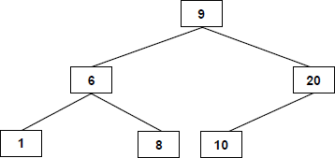
(i) A search of the binary tree is performed for the number 8.
List the numbers, in the order that they would be checked, for the search to determine that the number 8 is present in the tree.
______________________________________________________________
(1)
(ii) A search of the binary tree is performed for the number 11.
List the numbers, in the order that they would be checked, for the search to determine that the number 11 is not present in the tree.
______________________________________________________________
(1)
(g) The numbers 4, 5 and 3 are to be added into the binary search tree, in that order.
Figure 3 below is an identical copy of Figure 2.
Complete Figure 3 below to show the binary search tree from Figure 2 after the extra numbers have been added into it.
Figure 3
(2)
(Total 11 marks)
Q9.
The diagram below shows some production rules that have been used to define the syntax of valid mathematical expressions in a particular programming language.
<expression> ::= <factor> | <factor> * <factor> | <factor> / <factor>
<factor> ::= <term> | <term> + <term> | <term> - <term>
<term> ::= - <expression> | <number>
<number> ::= <digit> | <digit> <number>
<digit> ::= 0 | 1 | 2 | 3 | 4 | 5 | 6 | 7 | 8 | 9
(a) What notation method has been used in the diagram above?
___________________________________________________________________
(1)
(b) Complete the table below by writing Yes or No in the empty column to indicate whether or not the strings are valid examples of the statement types from the diagram above.

Statement type | String | Valid (Yes / No)
<number> | 129.376
<factor> | 23 + 17
(2)
(c) A tree can be used to demonstrate that an <expression> is valid. This is known as a parse tree.
Complete the parse tree below to show that 8 * 4 + 21 is a valid <expression>.
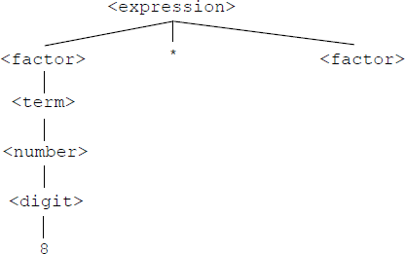

(3)
(Total 6 marks)
Q10.
For the expression 3+x the binary tree stores + at the root, 3 at the left hand node and x at the right hand node. If the nodes of this tree are printed as the tree is traversed, what will be printed when the traversal is
(a) pre-order; __________________________________________________________
(b) in-order; ___________________________________________________________
(c) post-order? _________________________________________________________
(Total 3 marks)
Mark schemes
Q1.
(a) All marks AO2 (analyse)

 | 1 | 2 | 3 | 4 | 5 | 6
1 | 0 | 2 | 5 | 3 | 0 | 8
2 | 2 | 0 | 1 | 0 | 0 | 0
3 | 5 | 1 | 0 | 0 | 0 | 4
4 | 3 | 0 | 0 | 0 | 1 | 0
5 | 0 | 0 | 0 | 1 | 0 | 5
6 | 8 | 0 | 4 | 0 | 5 | 0
Alternative answer

 | 1 | 2 | 3 | 4 | 5 | 6
1 | 0 | 2 | 5 | 3 | 0 | 8
2 |  | 0 | 1 | 0 | 0 | 0
3 |  |  | 0 | 0 | 0 | 4
4 |  |  |  | 0 | 1 | 0
5 |  |  |  |  | 0 | 5
6 |  |  |  |  |  | 0
Alternative answer

 | 1 | 2 | 3 | 4 | 5 | 6
1 | 0
2 | 2 | 0
3 | 5 | 1 | 0
4 | 3 | 0 | 0 | 0
5 | 0 | 0 | 0 | 1 | 0
6 | 8 | 0 | 4 | 0 | 5 | 0
Mark as follows:
1 mark 0s in correct places
1 mark all other values correct
I. non-zero symbols used to denote no edge but only for showing no edge going from a node to itself
2
(b) All marks for AO1 (understanding)
Adjacency list appropriate when there are few edges between vertices // when graph/matrix is sparse; NE. few edges
Adjacency list appropriate when edges rarely changed;
Adjacency list appropriate when presence/absence of specific edges does not need to be tested (frequently);
A. Alternative words which describe edge, eg connection, line, arc
Max 2
2
(c) Mark is for AO2 (apply)
It contains a cycle / cycles;
1
(d) Mark for AO1 (knowledge)
A graph where each edge has a weight/value associated with it;
1
(e) All marks AO2 (apply)
Mark as follows:
I. output column
1 mark first value of A is 2
1 mark second value of A is 5 and third value is 3
1 mark fourth and subsequent values of A are 8, 3, 7, 4, 9 with no more values after this
1 mark D[2] is set to 2 and then does not change
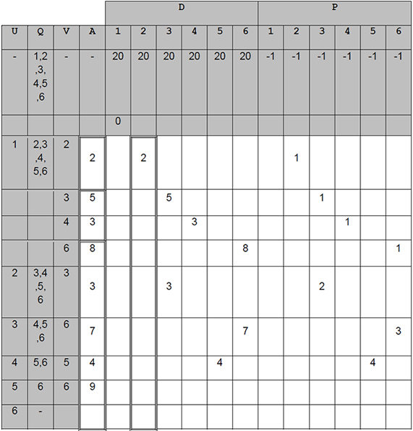
1 mark D[3] is set to 5 and then changes to 3 and does not change again
1 mark correct final values for each position of array P
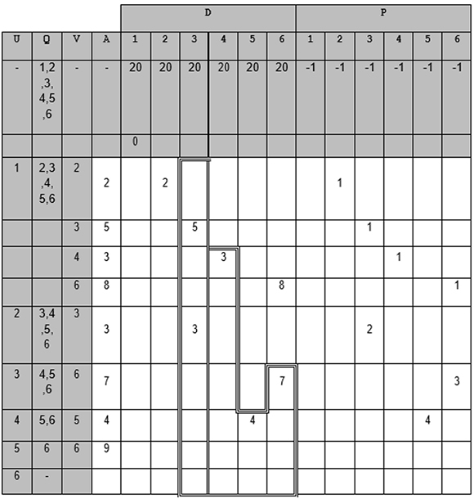
1 mark correct final values for D[1], D[4], D[5], D[6]
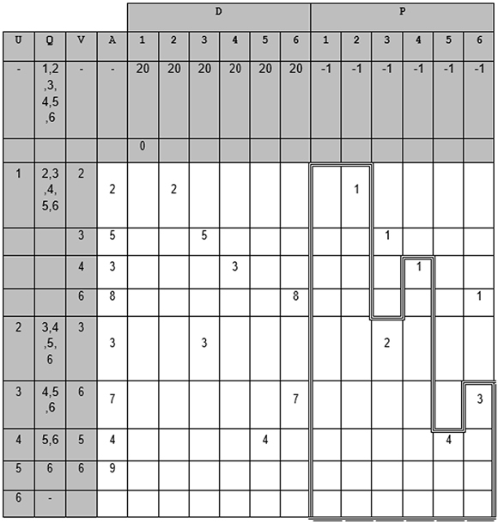
Max 6 marks if any errors
7
(f) Mark is for AO2 (analyse)
The shortest distance / time between locations/nodes 1 and 6;
NE distance / time between locations/nodes 1 and 6
R. shortest route / path
1
(g) All marks AO2 (analyse)
Used to store the previous node/location in the path (to this node);
Allows the path (from node/location 1 to any other node/location) to be recreated // stores the path (from node/location 1 to any other node/location);
Max 1 if not clear that the values represent the shortest path
Alternative answer
Used to store the nodes that should be traversed;
And the order that they should be traversed;
Max 1 if not clear that the values represent the shortest path
2
[16]
Q2.

(a)
Description | Correct letter (A-D)
A graph that is not connected. | B;
A graph that is a tree. | A;
If a letter has been used more than once then mark it as correct in the row that it is correct in, if any.
2
(b) Example 1
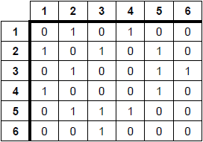

Example 2
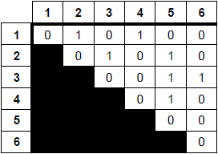
1 mark for labelling matrix with indices running from 1 to 6 on both axis and filled only with 0s and 1s, or some other symbol to indicate presence / absence of edge. e.g. T / F (allow a third symbol along diagonal). Absence can be represented by an empty cell.
1 mark for correct values entered into matrix, as shown in either example above
In Example 2, the shaded portion can be in either half − some indication must be made that half of the matrix is not being used. This could just be leaving it blank, unless the candidate has also represented absence of an edge by leaving cells blank.
Allow use of a third symbol in the central diagonal to indicate it unused, as it would not make sense to use it in this example.
Accept column and row labels in any order so long as they correspond to the data i.e. do not have to be in sequence 1 to 6.
2
(c)
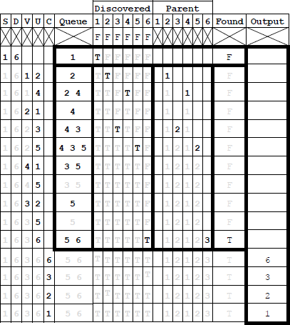
1 mark for having the correct value changes in each region highlighted by a rectangle and no incorrect changes in the region. Ignore the contents of any cells that are not changed.
A Alternative indicators that clearly mean True and False.
A It is not necessary to repeat values that are already set (shown lighter in table)
A For the queue column, for cells that should only have one value in them, accept if the student has written out the value twice at both the Front and the Rear, so long as this has been done consistently throughout the table. eg “4” written as “4 4”.
6
(d) So that packets / data arrive as quickly as possible / more quickly / with lower latency;
So that packets / data are delivered at lower cost / lowest cost;
So that routers do not have to process more packets / data due to unnecessary hops being made;
NE it is quicker without clarifying what “it” refers to
MAX 1
1
[11]
Q3.

(a) Connected // There is a path between each pair of vertices;
Undirected // No direction is associated with each edge;
Has no cycles // No (simple) circuits // No closed chains // No closed paths in which all the edges are different and all the intermediate vertices are different // No route from a vertex back to itself that doesn’t use an edge more than once or visit an intermediate vertex more than once;
A no loops
Alternative definitions:
A simple cycle is formed if any edge is added to graph;
Any two vertices can be connected by a unique simple path;
Max 1
(b) No route from entrance to exit / through maze;
Maze contains a loop/circuit ;
A more than one route through maze;
Part of the maze is inaccessible / enclosed;
R Responses that clearly relate to a graph rather than the maze
Max 1
(c)
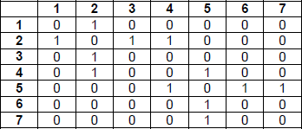
(allow some symbol in the central diagonal to indicate unused)
or
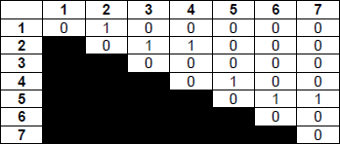
(with the shaded portion in either half – some indication must be made that half of the matrix is not being used. This could just be leaving it blank, unless the candidate has also represented absence of an edge by leaving cells blank)
1 mark for drawing a 7x7 matrix, labelled with indices on both axis and filled only with 0s and 1s, or some other symbol to indicate presence/absence of edge. e.g. T/F. Absence can be represented by an empty cell.
1 mark for correct values entered into matrix, as shown above;
2
(d) (i) Routine defined in terms of itself // Routine that calls itself;
A alternative names for routine e.g. procedure, algorithm
NE repeats itself
1
(ii) Stores return addresses;
Stores parameters;
Stores local variables; NE temporary variables
Stores contents of registers;
A To keep track of calls to subroutines/methods etc.
Max 1
Procedures / invocations / calls must be returned to in reverse order (of being called);
As it is a LIFO structure;
A FILO
As more than one / many return addresses / sets of values may need to be stored (at same time) // As the routine calls itself and for each call/invocation a new return address / new values must be stored;
Max 1
2
(e)
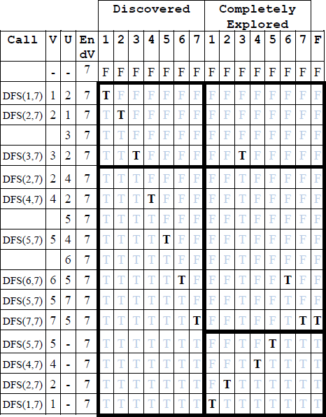
1 mark for having the correct values changes in each region highlighted by a rectangle and no incorrect changes in the region. Ignore the contents of any cells that are not changed.
A alternative indicators that clearly mean True and False.
A it is not necessary to repeat values that are already set (shown lighter in table)
5
[12]
Q4.

(a)
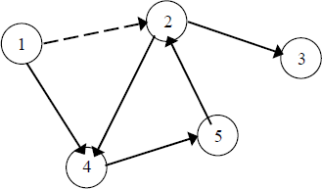
1 mark for all 5 lines correctly drawn
1 mark for all 5 arrowheads pointing in correct directions
Max 1 if more than 5 lines drawn by candidate (note that dotted arrow is given in question)
A arrowheads at any position on line
2
(b) Adjacency matrix appropriate when there are many edges between vertices // when edges may be frequently changed // when presence/absence of specific edges needs to be tested (frequently)
Adjacency list appropriate when there are few edges between vertices // when graph is sparse // when edges rarely changed //when presence/absence of specific edges does not need to be tested (frequently)
A alternative words which describe edge e.g. connection, line
2
(c) Connected // There is a path between each pair of vertices;
Undirected // No direction is associated with each edge;
Has no cycles // No (simple) circuits // No closed chains // No closed paths in which all the edges are different and all the intermediate vertices are different // No route from a vertex back to itself that doesn’t use an edge more than once or visit an intermediate vertex more than once;
Alternative definitions:
Graph with no cycles, and a simple cycle is formed if any edge is added to it;;
Graph which is connected, and it is not connected anymore if any edge is removed from it;;
Graph in which any two vertices can be connected by a unique simple path;; (Note: not just adjacent vertices)
Graph which is connected and has n - 1 edges where n is no of vertices;;
Graph which has no simple cycles and has n - 1 edges where n is no of vertices;;
Max 2
(d)
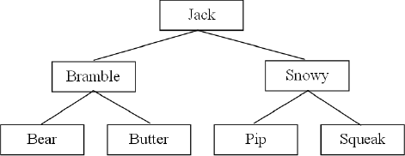
1 mark for Jack as root
1 mark for Bramble and Snowy as children of Jack
1 mark for four correct children of Bramble and Snowy
DPT if arrows drawn instead of lines
DPT if any node has more than 2 child nodes
A “mirror image” answers which are consistent.
3
(e) For solution with 3 arrays:
One array stores data items;
One array for left child pointers;
One array for right child pointers;
Pointers stored at same location in arrays as corresponding data item;
For solution with 1 array of records:
Record created to store data item and pointers;
One pointer to left child;
One pointer to right child;
For either of the above solutions:
Rogue value (allow example) used to indicate no child;
Variable indicates position in array(s) of root node // Root node stored at first location/start of array(s);
If answered as diagram:
Column for data with at least three correct data items in it;
Use of rogue value for a node that does not have child;
Correct value for a start pointer variable indicating position of root node in the array (not drawn as an arrow, array indices must be labelled);
Column for left child pointers*;
Column for right child pointers*;
* = To get these marks, there must be a sufficient number of pointers to demonstrate that the data structure is a representation of a binary tree, but it is not necessary for every item to be shown. Also the array indices must be shown.
Max 3
[12]
Q5.
Mark is for AO1 (understanding)
Directed (graph) // digraph;
[1]
Q6.
(a) John, Rachel, Paul;
R. If not in correct order
I. Incorrect spellings of names, as long as the name is comprehensible
I. Quotation marks
1
(b)
 | Time Complexity | Tick one box
 | O(n)
 | O(log n) | ✔
 | O(n²)
A. Alternative symbol which clearly indicates just one box e.g. cross, Y, Yes
R. Answers in which more than one row is ticked
1
(c) 1 mark for Start Index containing the index of the array item storing the root node (John)
1 mark for John, Hannah and Rachel being stored, each with left and right pointer values storing the indices of the correct child nodes
1 mark for Bradley, Jo, Paul and Tina being stored, each with left and right pointers storing appropriate rogue values e.g. -1, 0, NIL, NULL R. A dash or blank as the rogue value
Three example solutions are shown below, but the data items can be stored at any positions within the array, as long as the pointers correctly reflect this.
Start Index = 1

 | Index | Left Pointer | Data | Right Pointer
 | [1] | 2 | John | 3
 | [2] | 4 | Hannah | 5
 | [3] | 6 | Rachel | 7
 | [4] | –1 | Bradley | –1
 | [5] | –1 | Jo | –1
 | [6] | –1 | Paul | –1
 | [7] | –1 | Tina | –1
Start Index = 4

 | Index | Left Pointer | Data | Right Pointer
 | [1] | –1 | Bradley | −1
 | [2] | –1 | Jo | –1
 | [3] | 1 | Hannah | 2
 | [4] | 3 | John | 6
 | [5] | –1 | Paul | –1
 | [6] | 5 | Rachel | 7
 | [7] | –1 | Tina | –1
Start Index = 1

 | Index | Left Pointer | Data | Right Pointer
 | [1] | 2 | John | 5
 | [2] | 3 | Hannah | 4
 | [3] | –1 | Bradley | –1
 | [4] | –1 | Jo | –1
 | [5] | 6 | Rachel | 7
 | [6] | –1 | Paul | –1
 | [7] | –1 | Tina | –1
3
(d) Difference between Static and Dynamic (2 marks):
Static structures have fixed (maximum) size whereas size of dynamic structures can change // Size of static structure fixed at compile-time whereas size of dynamic structure can change at run-time;
Static structures can waste storage space/memory if the number of data items stored is small relative to the size of the structure whereas dynamic structures only take up the amount of storage space required for the actual data;
Static structures (typically) store data in consecutive memory locations, which dynamic data structures (typically) do not //
Dynamic data structures (can) (require memory to) store pointer(s) to the (next items which static structures typically do not need); MAX 2
A. Just one side of points, other side is by implication
Heap (1 mark):
Memory allocated/deallocated at run-time/for new items (to dynamic data structure);
(Provides a) pool of free/unused/available memory;
N.E. To store new items
3
(e) (i) Bradley, Hannah, Jo, John, Paul, Rachel, Tina;
R. If not in correct order
I. Incorrect spelling of names, so long as name is comprehensible
I. Quotation marks
1
(ii) (Ascending) Alphabetic order;
A. Alphabetic, it is sorted
1
(f) Graph may contain cycles / loops / circuits (so must keep track of which nodes already visited);
Graph may not be connected (so some nodes may be unreachable);
Graph may be weighted (so a more complex algorithm that accounts for the weights may be required);
N.E. Graphs can be directed
MAX 1
1
[11]
Q7.

(a) +;
4, 9, 6; (in any order)
2
(b) A Store the data / value (in the vertices / nodes);
A: holds the expression
B: Left pointer // points to the left child / left sub tree;
C: Right pointer // points to the right child / right sub tree;
A “indicates”, "index" or other synonym for “points” / “pointer”
R Stores left / right subtree
3
(c) The node has no left child / sub tree;
A there is nothing to the left
A this is a null pointer
1
(d) One mark for each area outlined with a dark rectangle. Lines that are not outlined can be missed out.
Alternative 1Alternative 2
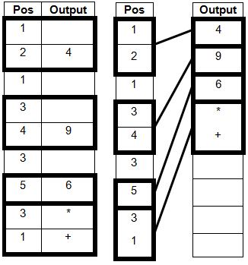
Mark against whichever alternative gives the highest mark.
Stop marking as soon as incorrect output is given.
4
(e) Post-order;
A Depth-first
A Depth-first search as BOD
TO Depth-first pre / in-order
1
(f) ( 4 + 9 * 6 in) Reverse Polish (Notation) // Postfix (Notation) // RPN;
1
[12]
Q8.

(a)
Algorithm Name | Requires Sorted  List? (Tick one box)
Binary search
Linear search
1 mark for having a tick in the "Binary search" row.
A alternative indicators for tick eg "Yes"
A a tick for "Binary search" and a cross for "Linear search"
R answers where two ticks have been used.
1
(b)
 |  |  |  | List
List  Length | Outer  Pointer | Current  Value | Inner  Pointer | [1]  9 | [2]  8 | [3]  5 | [4]  6
4 | 2 | 8 | 1 |  | 9
 |  |  | 0 | 8
 | 3 | 5 | 2 |  |  | 9
 |  |  | 1 |  | 8
 |  |  | 0 | 5
 | 4 | 6 | 3 |  |  |  | 9
 |  |  | 2 |  |  | 8
 |  |  | 1 |  | 6
Award 1 mark for each of the highlighted rectangles which has the correct values written in it in the unshaded cells.
Accept responses in which correct values are unnecessarily written out again.
Do not award a mark for any rectangle which has an incorrect value written in it.
3
(c) The value being moved / CurrentValue / 6 does not need to be put at the start of the list / / should be inserted at position 2 not position 1;
Because the second condition (in the While statement) is not satisfied;
MAX 1
1
(d)
Order of Time Complexity | Tick one box
O(n)
O(n²)
O(2^{n})
A alternative indicators instead of a tick eg a cross, Y, Yes
R responses in which more than one box is ticked
1
(e) Insertion sort;
A Insert sort
1
(f) (i) 9, 6, 8;
Must be in the order above. Can be separated by any character or a space
1
(ii) 9, 20,10;
Must be in the order above. Can be separated by any character or a space.
1
(g)
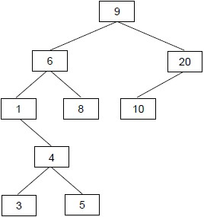
1 mark for inserting number 4 in the correct place
1 mark for inserting both numbers 3 and 5 in the correct place relative to 4
MAX 1 if any numbers added in the wrong place / any extra numbers added
2
[11]
Q9.

(a) Backus-Naur (Form);
A Backus Normal (Form), BNF, Extended Backus-Naur (Form), Augmented
Backus-Naur (Form), ABNF
A Misspellings of Backus-Naur
A Format for Form and the word “Notation”
R BN
1
(b)
Statement Type | String | Valid (Yes / No)
<number> | 129.376 | No;
<factor> | 23 + 17 | Yes;
A Alternative clear indicators of Yes or No e.g. Y / N, Tick / Cross, Valid / Invalid, True / False
2
(c)
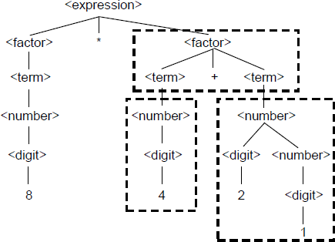
1 mark for each area surrounded by a rectangle
A missing chevrons
DPT Arrows drawn instead of lines
3
[6]
Q10.

(a) +3x;
1
(b) 3+x;
1
(c) 3x+;
1
[3]

