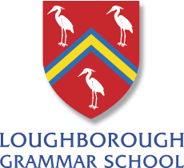

Studying International Relations in the UK

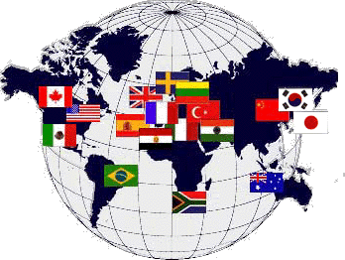

A Guide for Prospective Undergraduates, 2018

M Dawkins

Why International Relations?
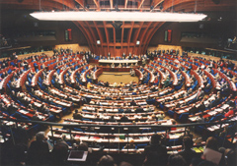
In today's increasingly interdependent and turbulent world, many of the leading issues in the news concern international affairs. Whether it is the continuing impact of globalisation, the military conflicts in the Gulf or Afghanistan, the inequalities of wealth and power between north and south or the activities of international organisations such as the World Trade Organization, the International Monetary Fund and the United Nations - all these have brought the subject of international relations directly into people's daily lives.
However, a degree in International Relations takes you far beyond the headlines, enabling you to reflect in a systematic and informed way on the deeper issues behind the news. In particular:
- it introduces you to the social, economic and political history of the international system as it has emerged and developed over the last 200 years;
- it provides you with the ideas of key classical and modern thinkers who have analysed world politics and have argued over its rights and wrongs;
- it gives you the opportunity to develop focused knowledge and understanding in specialised areas of your choice such as international law, global environmental change, international organisation, security studies and so on.
An increasing number of universities now offer a BA degree in International Relations as a distinctive field of study within the political sciences. Like more traditional Politics awards, International Relations degrees are usually classified into three main types: ‘single honours’ (focusing upon just International Relations), ‘joint honours’ (International Relations and another subject), and ’combined honours’ (where a minimum of a third of your time is spent studying International Relations in conjunction with what is usually a diverse range of subjects available).
Most include certain core courses that are designed to give you a wide intellectual foundation - combining perspectives from history, social theory, politics and political economy - on which to build your understanding of world politics today.

What sort of career could I have?
International Relations graduates go on to pursue a range of successful careers. A small number work in government foreign ministries, or in international organisations such as the European Union and the UN. Others find employment with internationally oriented non-governmental organisations such as Oxfam and Save the Children, or with multinational corporations. For a large number, their degree is the basis for a career in the media - in all its forms. And of course some will stay on for further study.

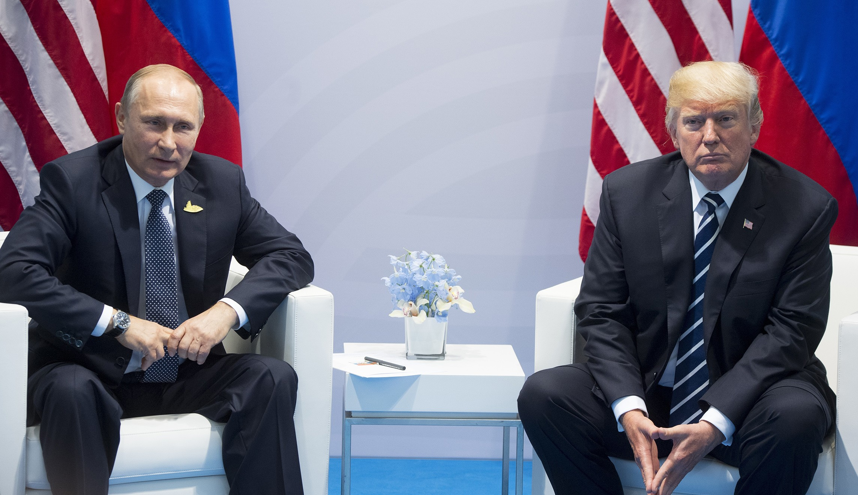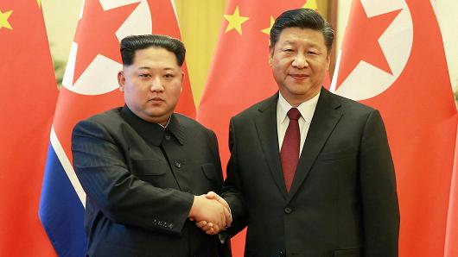

How will I learn?
Reflecting the modularity system operated by most universities, teaching methods change as you become an increasingly independent, self-directed learner. Core courses invariably are offered in the first and second years and normally are taught by weekly lectures, group discussions/seminars and, in better universities, with tutorials (It is worth noting that common practice now requires students to attend seminars as well as tutorials as a matter of discipline). It is increasingly the case that final-year courses are based entirely on seminar teaching. Similarly, the pattern of assessment is designed to promote different kinds of intellectual and practical skills at each stage, reflecting your developing academic independence.

What will I achieve?
- Good courses ensure that you receive a rigorous grounding in the subject. For example, you should gain an understanding of the core concepts and questions that define international relations; familiarity with the key theoretical traditions of International Relations as an academic discipline; a knowledge of the history of modern international relations; awareness of the major practical, political and moral challenges facing contemporary global society; the ability to use a variety of intellectual approaches when analysing international events and processes and an in-depth understanding of your chosen specialist areas.
- You should acquire a range of intellectual skills for example in the retrieval and use of primary and secondary information sources and in presenting concise, critical and cogently structured arguments, both orally and in writing.
- Successful students ought to have gained practical skills, such as the ability to work both independently and in cooperation with others; the ability to deploy a range of communication and information technology skills, and the ability to reflect upon and take responsibility for your own learning, making use of constructive feedback.

For those interested in studying International Relations, further information can be gained from the school library, where reference books and university prospectuses are available. Feel free to ask for further advice from me, or you could contact Departments directly to pose questions. All good Departments offering undergraduate programmes will welcome your inquiries. Alternatively, you could try:

UCAS: www.ucas.ac.uk

British International Studies Association: www.internationalstudies.ac.uk

